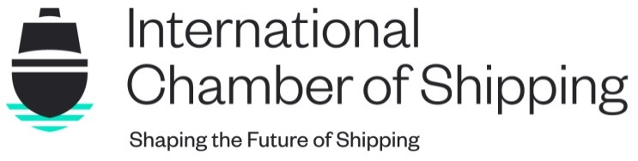
Walsingham House
35 Seething Lane
London
EC3N 4AH

Tel +44 20 7090 1460

info@ics-shipping.org | ics-shipping.org

This Circular and its attachments (if any) are confidential to the intended recipient and may be privileged. If you are not the intended recipient, you should contact ICS and must not make any use of it.

30 January 2023 COMMUNICATIONS(23)05

TO: COMMUNICATIONS LEADS

COPY: BOARD MEMBERS
PRESS
SHIPPING POLICY COMMITTEE

PRESS RELEASE: ICS PUBLISHES ANNUAL SHIPPING INDUSTRY FLAG STATE PERFORMANCE TABLE

Action Required: Comms leads are kindly asked to take note of the launch of the press release issued today announcing that the ICS annual Flag State Performance Table has been published.

The annual Shipping Industry Flag State Performance Table, published today from the International Chamber of Shipping (ICS), highlights a 25% increase in flag states reporting on seafarer labour standards compared to last year.

The Table also reports that a record number of flag administrations (49) have achieved full qualification status this year under the US Coast Guards Qualship21 programme. The initiative seeks to reward those companies, operators, and vessels that demonstrate the highest commitment to quality and safety through the highest level of compliance with International standards and United States laws and regulation.

For the full press release please click Annex A below.

For any further information contact: hannah.patmore@ics-shipping.org

COMMUNICATIONS(23)05 –Annex A – Press Release – ICS publishes annual Shipping Industry Flag State Performance Table

Hannah Patmore
Communications Executive

